Predictive Models in ICU Databases
Alain Areeba Siddiqui, Darlene Eligado, Mariah Noelle Cornelio
DATA 4381: Data Capstone Project 1
Project Advisor: Dr. Masoud Rostami
October 10, 2025

Introduction
Intensive Care Units (ICUs) represent the frontline of critical healthcare, where timely and accurate clinical decisions can mean the difference between life and death. Yet, behind the abundance of clinical data lies an often-overlooked reality — healthcare disparities that remain hidden within this data. Variations in the frequency of vital sign monitoring, inconsistencies in charting practices, and disproportionately high rates of false-positive diagnoses among minority populations raise a critical question: Is every patient truly receiving the same level of care? Differences in care inevitably lead to differences in outcomes, highlighting the urgent need to understand and address bias in ICU settings.
Machine learning (ML) has shown immense potential in predicting key outcomes such as ICU mortality and readmission risk by leveraging demographic, physiological, and contextual data. However, the same models that promise objectivity can inadvertently perpetuate existing disparities if bias is not explicitly addressed during model development. Factors such as data imbalance, missing contextual information (like hospital site or charting practices), and limited fairness considerations can all skew model performance — often disadvantageous to underrepresented or vulnerable patient groups.
Our project aims to use machine learning methods to evaluate ICU mortality and readmission risk while examining potential bias through the lens of fairness metrics. By systematically comparing model performance across different demographic groups and hospital contexts, this research aims to uncover patterns of disparity that may influence clinical decision-making. The ultimate objective is to design models that are not only accurate but also equitable, targeting a minimum recall of 70% across both outcome classes to ensure that no group is left under-identified.
The expected outcomes of this work include the development of nuanced, robust, and context-aware predictive models that enhance clinical decision-making and lay the groundwork for inclusive healthcare policies. By integrating fairness from the outset, this research strives to drive systemic change in ICU standards of care—moving toward a future where advanced analytics support both performance and equity in patient outcomes.

Dataset
Our project uses the eICU Collaborative Research Database (Demo, v2.0.1), a free multi-hospital ICU dataset available through PhysioNet (Johnson, Pollard, Badawi, & Raffa, 2021). The database comes in a SQLite file (.sqlite3) with 31 tables that hold information about ICU stays. For this study, we are planning to focus on 11 main tables: patient, apachePatientResult, apacheApsVar, apachePredVar, diagnosis, admissionDx, lab, vitalPeriodic, nurseCharting, intakeOutput, and hospital. These tables cover patient details, lab and vital sign data, ICU scoring results, and hospital level information.
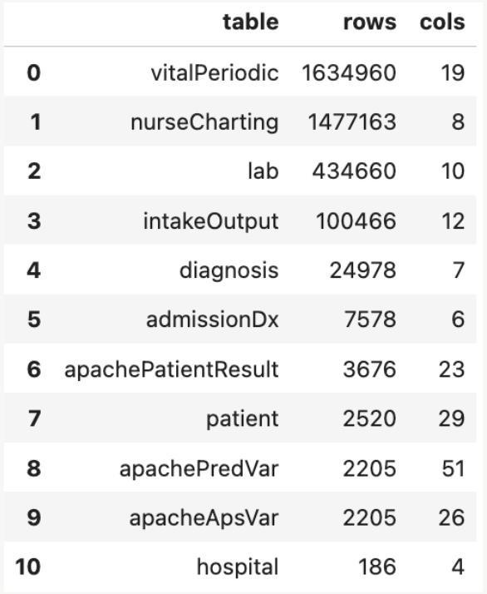
Figure 1: Outline of tables with the amount of rows and columns in each used in our study

The patient table includes demographics (like age, sex, and ethnicity), admission and discharge times, and discharge status. For mortality outcomes, we will mainly use the apachePatientResult table, which has both observed outcomes and risk predictions from the APACHE IVa model. This is a scoring system that estimates a patient’s risk of death based on their age, vital signs, and lab results (European Journal of Medical Research, 2022). The apacheApsVar and apachePredVar tables then provide the variables used to generate those predictions.

Reasons for admission and illness severity are under the diagnosis and admissionDx tables. Changes in patient condition are tracked through labs (lab table), vital signs (vitalPeriodic), and nurse notes (nurseCharting). Other important measures include glucose, creatinine, BUN, and heart rate. Fluid balance is recorded in the intakeOutput table, and the hospital table provides the details about the hospitals themselves, like region and type.

The size of the dataset varies amongst the tables, with some tables (like patient) containing thousands of rows, while time-series tables like vitalPeriodic and nurseCharting contain millions. Early looks into the the data show:
- Mortality outcomes are imbalanced, since most patients survived.
- Many variables, such as diagnosis or ethnicity, have a large number of categories.
- There are missing values in time-series data (especially labs and vitals).
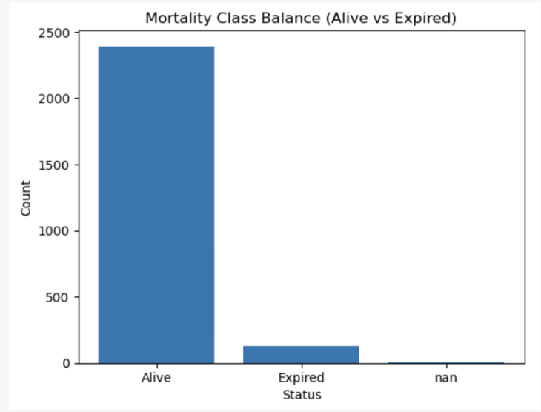
Figure 2.1: Class imbalance between alive and expired mortality status in our dataset, including missing values.
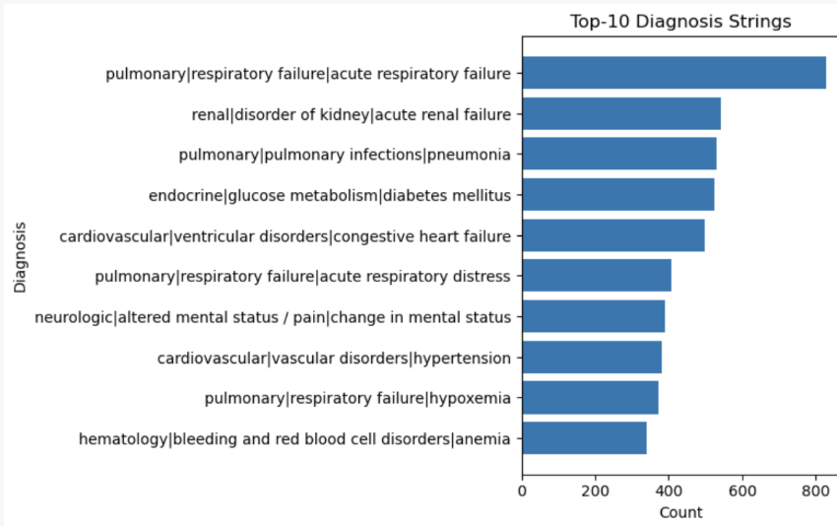
Figure 2.2: Top 10 Diagnosis strings listed but up to 1000+ unique categories in this category
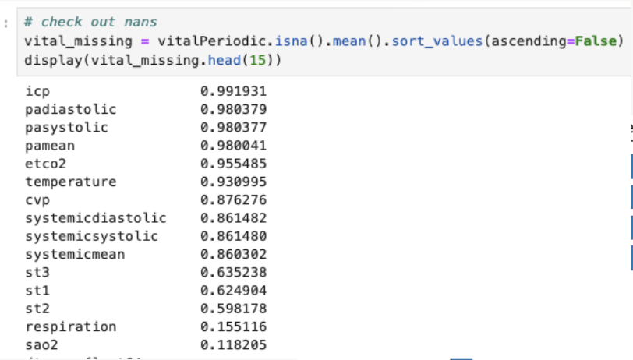
Figure 2.3: Average of missing values in the vitals category
These patterns bring challenges for preparing the data, such as dealing with missing values, balancing uneven outcomes, and simplifying many different categories. Handling these issues will be important for building models that are both more reliable and fair.
Methodology
In this Capstone 1 project, we will develop and evaluate two separate predictive pipelines: one for in-hospital mortality and another for hospital readmission. Treating these as distinct classification tasks will allow us to tailor preprocessing, class balance handling, and evaluation strategies to the unique characteristics of each clinical outcome so that we may be able to explore bias regarding these scenarios, if any. For mortality prediction, we will use the variable “hospitaldischargestatus” as the label. For readmission prediction, we will derive a binary flag from “patientstayid” to indicate repeated visits or readmission within the dataset.
For exploratory data analysis (EDA), we will begin with a comprehensive exploration of the dataset to understand its scale, structure, and potential challenges. The number of rows and columns will be inspected to gauge the dataset’s size. We will summarize numerical features with basic statistics to identify typical values, spread, and outliers. Histograms and bar charts will be used to visualize distributions of both numerical and categorical variables, revealing skewed data, imbalances, or anomalies. We will also examine class balance separately for mortality and readmission, as significant imbalance may bias predictions. Missing values will be quantified through heatmaps or percentage tables, and a correlation matrix or variance inflation factor (VIF) analysis will be performed to detect any multicollinearity that could distort model training. Outliers and noisy features will be flagged for potential removal or transformation.
For data preprocessing and cleaning, we will ensure all variables are in their correct data types so that algorithms handle them properly. Missing values will be addressed through imputation methods such as median, mean, or mode substitution to maintain data integrity without significant loss of information. Domain knowledge on hospital and healthcare processes will be applied heavily and carefully in this stage. Features will be normalized or standardized if required by algorithms sensitive to scale. Categorical variables will be encoded using one-hot or ordinal encoding to convert them into numeric form. For readmission prediction, we will explicitly create the binary readmission flag from “patientstayid”. These steps are essential to ensure that models are trained on consistent, high-quality input data.
In our modeling plan, we will compare multiple classification algorithms to assess their suitability for each task. Logistic regression will serve as a simple, interpretable baseline. Random forests will be tested for their robustness to noise and ability to capture non-linear relationships. Gradient-boosted trees (like XGBoost or LightGBM) will be included for their strong performance on structured tabular data. A simple neural network will be explored to evaluate whether non-linear, high-capacity models offer measurable gains. After running the mortality pipeline, we will run the same procedure for the readmission pipeline. If need be, we will play around with KNN and clustering (unsupervised models) and see if there are any interesting findings there. All modeling will be implemented in Python using scikit-learn, XGBoost, and PyTorch within a Jupyter Notebook environment.
For our model training strategy, the data for each target will be split into training, validation, and test sets using a 70/15/15 division to prevent overfitting and provide unbiased evaluation. Five-fold cross-validation will be applied during training to obtain robust performance estimates. Hyperparameters will be tuned using grid or random search. For the neural network, training will use a batch size of approximately 32–64 and run for 20–30 epochs, balancing convergence speed with stability. Computations will be performed on a personal computer with GPU and RAM support to ensure feasible training times.
Model performance will be primarily assessed using recall, as minimizing false negatives is critical in healthcare contexts, where failing to identify high-risk patients can have severe consequences. Secondary metrics will include precision, F1-score, AUROC, and AUPRC to provide a balanced evaluation of overall performance and reliability. Calibration plots will be used to assess probability estimates. Basic bias and fairness checks will be performed by stratifying recall, precision, and F1-score across demographic groups or hospital systems. Any noticeable disparities will be flagged, but no fairness interventions will be applied at this stage in Capstone 1. Error analysis will involve examining false positives and false negatives as well as feature importances or SHAP values to identify potential improvements.
For our Capstone 2 plan, we will expand the analysis to include full fairness assessments such as statistical parity difference, equal opportunity difference, and subgroup AUROC. If disparities are identified, fairness-aware methods such as reweighting or adversarial debiasing will be explored. We will also perform feature engineering and potentially apply model stacking to improve performance. If appropriate, the final model may be deployed as a simple web application or dashboard to demonstrate usability. Finally, we will prepare a poster or short paper to communicate our findings.
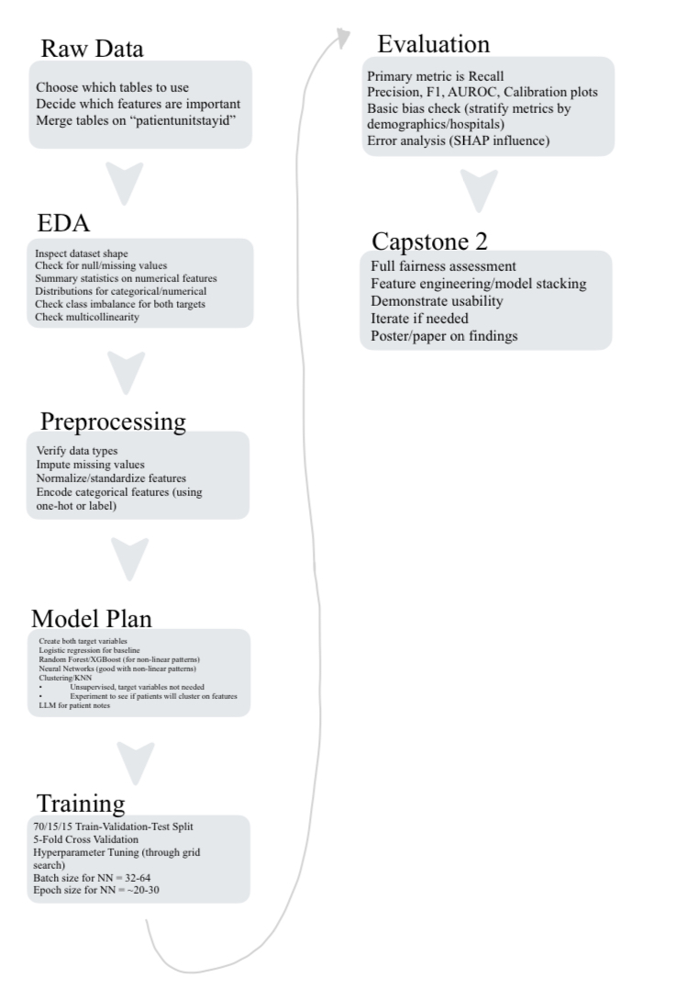
Figure 3: Flowchart pipeline of methodology and plan for Capstone 2

Applications and Deliverables
The applications of this project extend across the entire healthcare ecosystem, fostering collaboration among physicians, nurses, healthcare administrators and data scientists. By identifying where healthcare delivery systems fall short—whether in monitoring practices, diagnostic consistency, or equitable patient management—this research provides actionable insights that can inform both clinical workflows and institutional policies. Beyond model development, the findings can guide the creation of targeted training programs and professional etiquette standards aimed at reducing bias in patient care. The deliverables of this project will include poster presentations at the College of Science Discover Symposium (2026) and the UT System AI in Healthcare Symposium (2026), as well as a publication in Stimulus: The UTA Medical Humanities Journal. These outputs will not only disseminate key findings but also generate new leads for future interdisciplinary research, advancing the integration of fairness and accountability into the core of healthcare analytics.

References
Johnson, A., Pollard, T., Badawi, O., & Raffa, J. (2021). eICU Collaborative Research Database Demo (version 2.0.1). PhysioNet. https://doi.org/10.13026/4mxk-na84

European Journal of Medical Research. (2022). Evaluation of mortality prediction using SOFA and APACHE IV in critically ill patients: A retrospective study.
https://eurjmedres.biomedcentral.com/articles/10.1186/s40001-022-00822-9

Meng, C., Trinh, L., Xu, N., Enouen, J., & Liu, Y. (2022). Interpretability and fairness evaluation of deep learning models on MIMIC-IV dataset. Scientific Reports, 12, Article 7166. https://doi.org/10.1038/s41598-022-11012-2
Obermeyer, Z., Powers, B., Vogeli, C., & Mullainathan, S. (2019). Dissecting racial bias in an algorithm used to manage the health of populations. Science, 366(6464), 447–453. https://doi.org/10.1126/science.aax2342
Shi, J., Hubbard, A. E., Fong, N., & Pirracchio, R. (2025). Implicit bias in ICU electronic health record data: Measurement frequencies and missing data rates of clinical variables. BMC Medical Informatics and Decision Making, 25, Article 241. https://doi.org/10.1186/s12911-025-03058-9
Wang, H. E., Weiner, J. P., Saria, S., Lehmann, H., & Kharrazi, H. (2024). Assessing racial bias in healthcare predictive models: Practical lessons from an empirical evaluation of 30-day hospital readmission models. Journal of Biomedical Informatics, 156, 104683. https://doi.org/10.1016/j.jbi.2024.104683
Wang, H. E., Weiner, J. P., Saria, S., & Kharrazi, H. (2024). Evaluating algorithmic bias in 30-day hospital readmission models: Retrospective analysis. Journal of Medical Internet Research, 26(1), Article e47125. https://doi.org/10.2196/47125

